BACS2033 Software Requirements Engineering

Tutorial 1

Chapter 1

- With the aid of an example, discuss the THREE (3) main dimensions of SRE.

Dimension | Description | Example (E-commerce System)
WHY (Objectives) | Determines why a new system is needed by analyzing the problems of the current system and aligning with business goals. | The company wants to expand sales beyond physical stores and reduce manual order processing errors.
WHAT (Functionalities) | Defines what services and functions the new system must provide to meet the objectives. | Online ordering, payment gateway integration, order tracking, and inventory management.
WHO (Responsibilities) | Assigns who is responsible for each function or constraint—between software, users, and environment. | Software handles transaction validation; warehouse staff handle packaging; admin monitors orders.

WHY → Objectives & goals
WHAT → System functions & services
WHO → Role assignments & boundaries

Why dimension
- identify , analyze, define the system to be objective
- To address analyze deficiencies of the system, in alignment with business objective, taking advantage of technologies opportunities
- Eg: airport train control - “serve more passengers”

What dimension
- Identify and define the system to be functional services (software services, associated manual procedures)
- To statistive identify objective, based on realistic assumption about the environment
- Eg: airport train control - “computation of save train acceleration"

Who dimension
- Assign responsibility for the objective, services, constraint among system to be components
- Based on their capability of the system objectives
- Eg: airport train control - “under direct responsibility of software to be (driverless options) or driver following software indications”

- Recently you have been assigned to work on a project to implement an e-commerce system for a manufacturing company. This is the first time that your team ventured into this type of project implementation. You found that most of the client staff is not clear about the new system requirements. Furthermore, they were reluctant to accept the new system.

- Discuss the requirements engineering process that your team would perform for the above mentioned project. State the output(s) for each activity in the requirements engineering process.

Activity | Description | Outputs
- Domain Understanding & Elicitation | Study the current system and environment, identify stakeholders, understand company workflow and business goals. | Initial draft proposal, stakeholder list, glossary of key terms.
- Requirements Elicitation | Conduct interviews and workshops to discover user needs, problems, and improvement opportunities. | Preliminary requirements list, user stories, draft use cases.
- Evaluation & Agreement | Discuss and negotiate with clients to resolve conflicts and prioritize requirements. | Agreed requirements document, rationale for decisions.
- Specification & Documentation | Write detailed descriptions of functional and non-functional requirements in a structured document. | Software Requirements Specification (SRS) or Requirements Document (RD).
- Validation & Verification | Review and test requirements for correctness, completeness, and consistency. | Consolidated RD, acceptance criteria, prototype, and test data.

This process is iterative — if new information arises, earlier steps may be revisited.

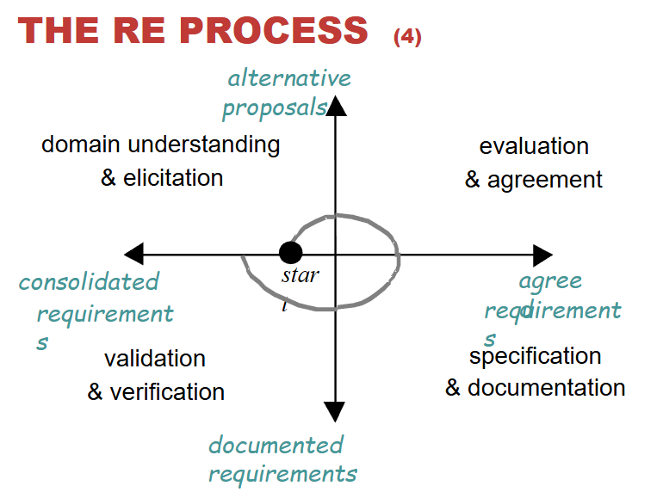
Domain understanding and elicitation
- Output: alternative solution
Requirement evaluation and agreement
- Output: Agree requirements
Requirement specification & documentation
- Output : documental requirement
Requirement validation & verification
- Output: validated and consolidated requirement

- Give and explain TWO (2) functional requirements and TWO (2) non-functional requirements for the above system.

Type | Requirement | Explanation
Functional 1 | The system shall allow customers to browse and purchase products online. | Defines a core feature — enables users to perform e-commerce transactions.
Functional 2 | The system shall send order confirmation emails after successful payment. | Specifies a function triggered by payment completion.
Non-Functional 1 | The system shall process payment transactions within 3 seconds. | A performance requirement defining speed.
Non-Functional 2 | The system shall be available 24/7 with 99% uptime. | A reliability/availability requirement ensuring constant accessibility.

FR
- View product details, purchase/order products, make online payment, check order delivery
NFR
- User friendly screen, reliability, efficiency, develop using OOAD methodology

- Differentiate Process requirements from Product requirements.

Type | Definition | Example
Product Requirements | Specify what the software must do or constraints on the product being developed. | “The system shall allow users to check out using credit card or e-wallet.”
Process Requirements | Specify how the software should be developed or managed during its creation. | “The system shall be developed using the Agile methodology.”
✅ Key Difference:
- Product requirements → concern the system itself
- Process requirements → concern the method of development
Product
- Is a need or constraint on the software to be developed.
- Eg: “the software shall verify that a student meet all pre-requirements before he/she register for a course”

Process
- Is essential a constraint on the developed of the software
- Eg: “The software shall be developed using Waterfall development process”

- Discuss any TWO (2) obstacles to good requirements engineering practice in a software project.

- Time and Cost Pressure
  - Teams often rush RE activities due to tight deadlines or budget constraints.
  - This leads to incomplete requirements or misunderstanding of client needs.
- Unclear Stakeholder Involvement
  - Clients may be unsure about what they need or resist change (as in the scenario).
  - Without active participation, requirements become vague and inconsistent.
Other possible obstacles (from slides): lack of RE economics data, overly complex documents, or fast-changing technology.
Requirement engineering effort often spend without guarantee of the object contract being concluded
Pleasure on type schedule, short term cost, catching out on technology
Tool support might be costly

- Give ONE (1) example for each part below to show:

  - Overlaps of functional and non-functional requirement

Example: “The system shall encrypt all customer data before storing it.”
Explanation:
Encryption is a function (something the system does) but also a security requirement (a non-functional quality).
Overlap of FR
- for firewall management features are security related (NFR)

  - Overlaps of non-functional requirement

Example: “The system shall respond to user requests within 2 seconds to ensure safe payment processing.”
Explanation:
This requirement relates to both performance and safety — two non-functional qualities that overlap.
Overlap of NFR
- Eg: “high frequency of train commands is related to performance and safety”

- Discuss the relationship of Agile Development with Requirements Engineering (RE).

Relationship:
Agile development incorporates RE activities in short, iterative cycles instead of one large upfront process.
Aspect | Agile RE Characteristics
Elicitation | Done continuously with customer collaboration and feedback.
Documentation | Lightweight — user stories replace lengthy requirement documents.
Validation | Occurs quickly through working software demonstrations.
Change Management | Changes are welcomed, even late in development.

Benefits:
- Early delivery of valuable functionality
- Quick feedback reduces misunderstanding
- Closer collaboration between developers and clients
Limitation:
Agile assumes small, co-located teams and fast decision-making; it may neglect detailed non-functional aspects or documentation.
Twelve Agility Principles
- Customer satisfaction by rapid delivery of useful software
- Welcome changing requirements, even late in development
- Working software is delivered frequently (weeks rather than months)
- Working software is the principal measure of progress
- Sustainable development, able to maintain a constant pace
- Close, daily co-operation between business people and developers
- Face-to-face conversation is the best form of communication (co-location)
- Projects are built around motivated individuals, who should be trusted
- Continuous attention to technical excellence and good design
- Simplicity- The art of maximizing the amount of work not done - is essential
- Self-organizing teams
- Regular adaptation to changing circumstances

